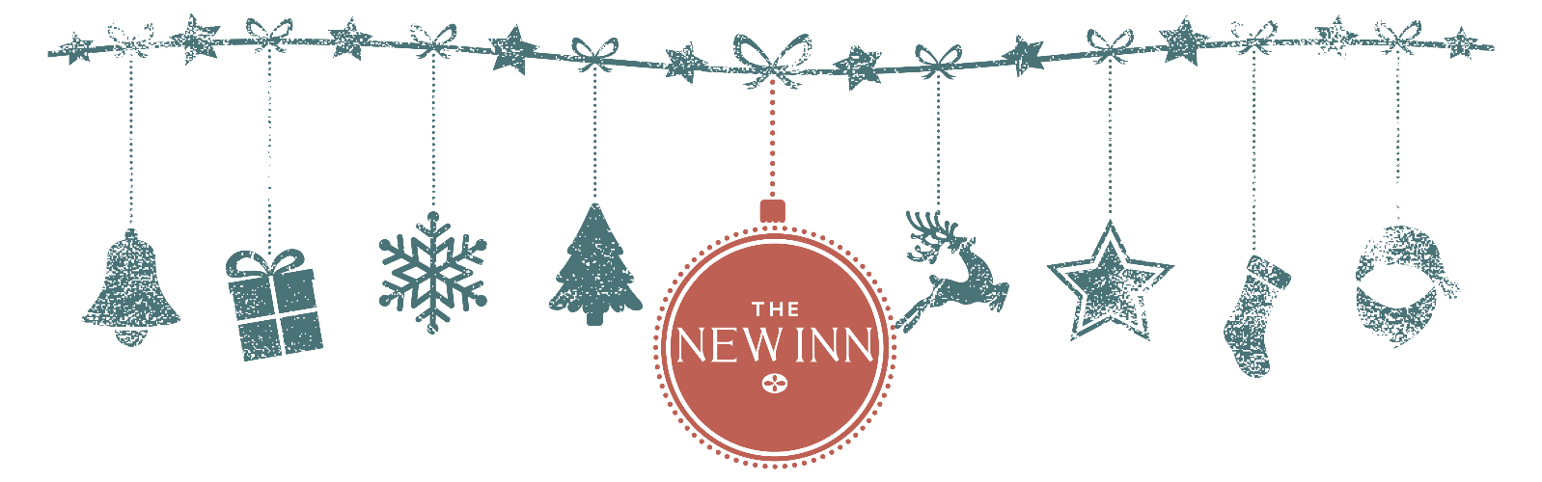

CHRISTMAS LUNCH

STARTER
Beetroot, orange & juniper cured trout, horseradish crème fraiche, orange, dill and pickled mustard seeds
Duck liver & Armagnac parfait, spiced plum, pickled walnuts, toasted brioche
Jerusalem artichoke and smoked garlic soup, hazelnut & thyme, house baked focaccia (v/vo)

MAIN
Turkey roulade, confit turkey leg, apricot, sage and chestnut stuffing, pigs in blankets, roast heritage carrots, mulled wine braised red cabbage, roast potatoes, turkey gravy
Pan roasted Cornish John Dory, smoked haddock brandade, Tresco spinach, mustard beurre blanc, chive oil
Celeriac and wild mushroom pithivier, Tresco spinach, salsify, Madeira and thyme jus (v/vo)

PUDDING
Zoe’s homemade Christmas pudding, brandy sauce
Sherry trifle, raspberry, orange, almond sponge, toasted almonds (v/vo)
Baron Bigod, quince jelly, Tresco plum chutney

TO FINISH
Origin filter coffee • Selection of teas • Petit fours

